Sec 5.7 – Tables

The system’s database entities are described below as to their role within the “package”. Columns within each table, as well as, relationships between tables are shown in the Entity Relationship Diagram (Appendix D).

5.7.1 ParkingLot

Stores a list of parking lots on campus that have handicapped parking available with a small description (e.g. Max Chambers Library – South Lot)

5.7.2 ParkingSpace

Stores a list of parking spaces within each lot along with a short description for each, a flag as to whether the space is currently in use and a querystring representing a set of navigational parameters to be passed to the Navigation system upon Driver request.

5.7.3 Driver

Stores a list of users of the system. Table handles user authentication through the password column and stores Email, phone and vehicle license plate info for communication from the system and between users.

5.7.4 LicensePlateStates

A simple lookup table of state names for license plate identification in association with the Driver vehicle.

5.7.5 Reservation

Stores the reservations that have been committed by the drivers. Each reservation has a relationship (foreign key) to each of the following respective entities: Driver, ParkingSpace, ReservationStatus. The start and end time for each reservation is additionally stored.

5.7.6 ReservationStatus

A lookup table containing a discrete list of statuses for use by the Reservation table to indicates the status of each reservation (ACTIVE, CANCELLED, COMPLETED).

5.7.7 Email_Message

Stores messages that have been sent (status=SENT) or are intended to be sent (status=PENDING) to drivers from the system over SMTP. Messages may also have a status of ERROR should an error be reported from the adapter.

5.7.8 SMS_Message

Stores messages that have been sent (status=SENT) or are intended to be sent (status=PENDING) to drivers from the system over SMS. Messages may also have a status of ERROR should an error be reported from the adapter.

Msg_Status

A lookup table containing a discrete list of statuses for use by the SMS_Message and Email_Message tables to indicates the status of each message (PENDING, SENT, ERROR).

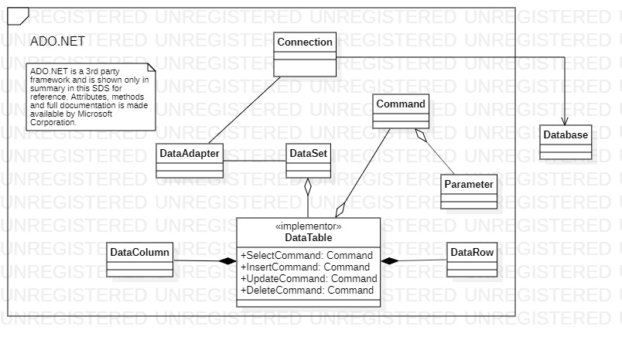

The SQL Services package is displayed above (fig. 5.8). All noted classes come directly from Microsoft’s ADO.Net framework (upon which the system’s DataBridge package depends). These are included here for completeness. Further documentation is available at <https://docs.microsoft.com/en-us/dotnet/framework/data/adonet/>